Portfolio Project

We are making a system where user can enter thier stock trades of NSE and BSE. Then system will show user their profits and losses.

User will register with username and password only. No emails or mobile number will be takes from user. Hence user has to take care of their password because password cannot be recovered.

Below attached is the login Screen:

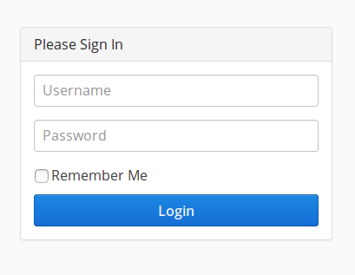

After loggin in user will land on following page called dashboard, image attached below:

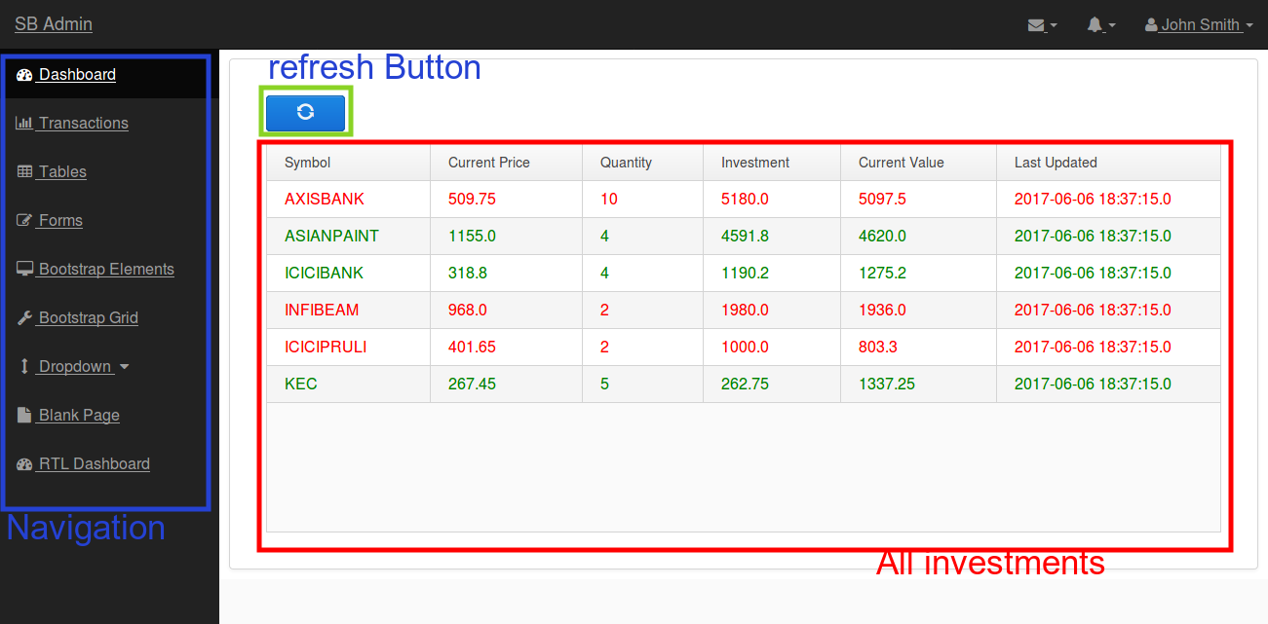

To manage trades which we call here transactions can manage in below given screen

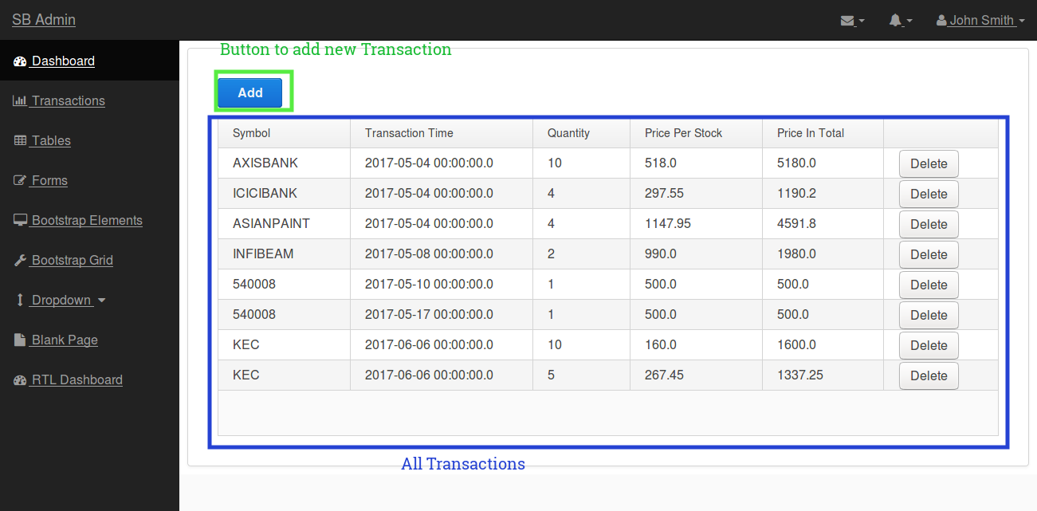

To add new Transaction just click on add button , a form will appear as given in image below:

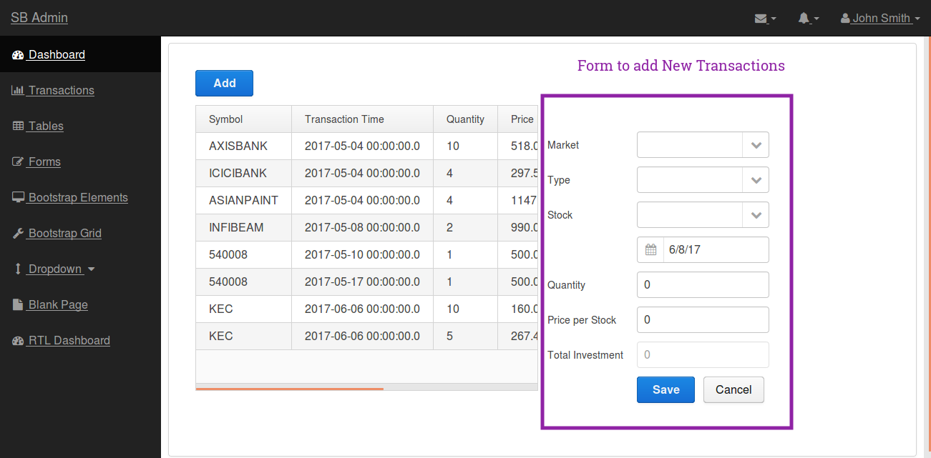

after adding new Transaction user can go to dashboard and clicks the refresh button to see updated investments.

Features for version 1.0
1. User registration
2. Dashboard
3. Add, Update and Delete Transaction.

